Stock Price Forecasting Using Time Series Analysis and Deep Learning: A Case Study on Apple Inc. (AAPL)

Divyanshu Singh, Akshat Khandelwal and Shlok Kohli
B.tech, CSE, Bennett University, Noida, India

Abstract

This study presents a comparative analysis of various time series forecasting models for forecasting Apple Inc. (AAPL) stock prices. Historical closing price data from Yahoo Finance, from January 2010 to January 2024, is used to train and test models like ARIMA, SARIMA, LSTM (Long Short-Term Memory), and Facebook Prophet. The data is initially tested for stationarity, followed by preprocessing and train-test split. Each model is optimized for accuracy using the respective statistical and machine learning techniques. The models are then compared using Root Mean Square Error (RMSE) and R² score metrics. Results indicate that although traditional statistical models like ARIMA and SARIMA are effective in capturing linear trends, deep learning-based LSTM and the Prophet model are more effective in capturing complex temporal relationships and seasonality. The study concludes with a comparative visualization of actual vs. predicted stock prices, with implications for model choice in financial forecasting.

Introduction
Stock price prediction is among the most important areas of finance analysis, which helps investors, analysts, and researchers make informed decisions in the present uncertain environment. Accurate stock price prediction not only provides a glimpse of the future direction of the market but also facilitates portfolio optimization and risk management. Among the world's top-performing listed companies, Apple Inc. (AAPL) is one of the leaders due to its commanding market share, aggressive innovation, and significant influence in the world's technology sector. As a result, Apple's stock price prediction is a widely discussed issue in financial prediction and time series prediction.
The nonlinear and dynamic behavior of stock markets requires the application of strong modeling techniques that can identify linear and nonlinear patterns. The conventional statistical models like ARIMA and SARIMA have been utilized because of their ability to handle stationary time series data. But the introduction of machine learning and deep learning methods, i.e., Recurrent Neural Networks (RNNs) and Long Short-Term Memory (LSTM) models, has enhanced the capability to learn from sequential data and respond to underlying trends and seasonality. Facebook Prophet, a modular additive time series forecasting model, also provides a simple and flexible means to capture change in trends and holidays.
1. Herein, we investigate and compare the forecasting ability of ARIMA, SARIMA, LSTM, and Prophet models through past closing price data of Company Apple Inc. between 2010 and 2024. Each model is thoroughly trained and tested based on common performance measures to ascertain its effectiveness in depicting market patterns. The aim is to find the most appropriate model for forecasting Apple's stock price and to examine the advantages and disadvantages of each method in a real-world finance scenario.

2. Related Work
Stock price prediction has been a subject of significant quantitative finance, econometrics, and machine learning research. Statistical approaches such as Autoregressive Integrated Moving Average (ARIMA) and its seasonal equivalent SARIMA have found extensive use in univariate time series prediction. These statistical techniques have sound theoretical backgrounds and work well in identifying linear patterns and seasonality in historical price changes. There is a vast literature that has evaluated their short-term prediction accuracy under conditions of stationarity.
Over the past few years, the emergence of machine learning and deep learning models has revolutionized time series forecasting. Methods like Long Short-Term Memory (LSTM) networks—a highly advanced version of Recurrent Neural Networks (RNNs)—have been discovered to have better ability to learn long-term dependencies and nonlinear patterns from sequential financial data. Experiments have shown LSTM to outperform traditional models when market data are extremely volatile and non-stationary, as in the case of the stock market.
Another important arrival is Facebook Prophet, a decomposable time series model with support for missing values, outliers, and trend changes. Prophet is easy to use and good at modeling multiple seasonalties and is thus well-suited to business and finance use cases. Prophet enables analysts to model daily, weekly, and yearly seasonality in time series without needing to be statistically inclined.
Earlier comparative research has been prone to juxtaposing such models to compare forecasting capacity in blue chip stocks and indices. For instance, studies on Apple Inc. and the like tech stocks have indicated that ARIMA is appropriate for stable, short-run trends but that LSTM and Prophet are superior when it comes to forecasting in the long run and are resilient against sudden trend shift and anomalies.
Keeping these developments in view, this project combines all four models—ARIMA, SARIMA, LSTM, and Prophet—to comprehensively compare their performance on Apple's past stock prices. The results try to give insights into model choice based on data trend, forecast horizon, and precision needs.

2.1 Different Approaches
To effectively predict Apple Inc.'s stock prices, the project employs a collection of time series forecasting models, each representing a distinct way of handling historical financial data. The four primary models used are ARIMA, SARIMA, LSTM, and Prophet. These models are chosen because they have complementary strengths to detect trends, seasonality, and nonlinear patterns in time series data.
ARIMA(AutoRegressive Integrated Moving Average)
ARIMA is a classical statistical model that combines autoregression (AR), differencing (I), and moving average (MA) components to modeling time series data. It assumes that future values are linearly dependent on past observations and past errors. ARIMA is suitable for non-seasonal data that can be made stationary and is effective in short-term predictions with stable patterns.
SARIMA (Seasonal ARIMA) SARIMA is a variation of ARIMA that incorporates seasonal terms and is used to model data that have recurring seasonal patterns. It adds extra parameters to include seasonal autoregressive, differencing, and moving average terms. SARIMA is particularly helpful when data have strong seasonal trends, such as yearly cycles that are typical in financial data.
1. LSTM (Long Short-Term Memory Networks)
LSTM is a deep network architecture in the class of recurrent neural networks (RNNs). LSTM is designed specifically to learn long-term dependencies and to solve the vanishing gradient issue with regular RNNs. The LSTM networks can learn intricate nonlinear patterns and are robust to regular noise and fluctuations in the stock price series. This makes them very effective at solving the problem of large data set-driven time series forecasts with intricate inter-temporal dynamics.
2. Prophet
Prophet is a model developed by Facebook and is an additive time series forecasting model based on additive regression. It breaks the data into trend, seasonality, and holiday. Prophet is able to handle missing values and outliers and is easy to parameter tune for beginners. Its ability to handle irregular trends and multi-seasonalities is its strongest point, which is common in real-world stock data.
Each of these techniques has its own particular contribution to making predictions. While ARIMA and SARIMA are theory-driven and are effective in extrapolating structured patterns, LSTM and Prophet provide flexibility and adaptability for real-world, complex scenarios. By comparing the models on the same dataset, we aim to determine which technique makes the most optimal and reliable predictions for Apple's stock price.
Proposed Methodology
The methodology of this project involves several sequential steps aimed at preprocessing the data, implementing multiple forecasting models, evaluating their performance, and comparing the results. Each stage is designed to ensure that the models are trained effectively and fairly evaluated on consistent data.
- Data Collection
Historical stock price data for Apple Inc. (AAPL) was collected from Yahoo Finance using the yfinance library in Python. The dataset spans from January 1, 2010, to January 1, 2024, and includes the daily closing prices, which serve as the primary variable for prediction.
- Data Processing
The dataset was cleaned by removing null values and unnecessary columns, retaining only the 'Close' price. The time series was visualized to understand the trend and fluctuations. To evaluate model performance, the dataset was split into two parts: 80% for training and 20% for testing. Additionally:
- Stationarity tests (ADF test) were performed to check for trends and seasonality.
- Differencing was applied where necessary to make the data stationary for ARIMA and SARIMA models.
- For LSTM, the data was normalized using MinMaxScaler and reshaped into sequences suitable for deep learning.
- Model Implementation
Four different models were implemented and trained:
  - ARIMA:
A grid search over combinations of p, d, q parameters was performed using AIC (Akaike Information Criterion) to select the optimal configuration. The model was then trained on the training dataset, and predictions were generated for the test period.
  - SARIMA:
Based on the best ARIMA order, a seasonal component was introduced with parameters (P, D, Q, s), where s = 12 for monthly seasonality. The model was fitted to the training set and forecasted on the test data.
  - LSTM:
A sequential neural network with two stacked LSTM layers followed by Dense layers was built using TensorFlow/Keras. A sequence length of 10 days was used to predict the next closing price. The model was trained over 20 epochs, and the output was scaled back to the original range for evaluation.
  - Prophet:
The data was reformatted to match Prophet's required structure with columns ds (date) and y (value). The model was trained on the training set, and future dates were generated to match the test period. Prophet then forecasted values based on trend and seasonality decomposition.

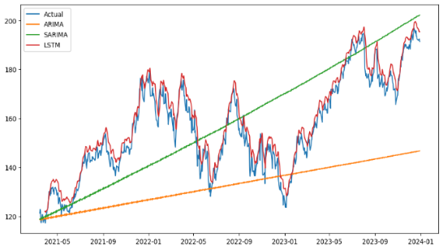
Figure 1: Comparison Graph

- Evaluation Metrics
The performance of each model was evaluated using the following metrics:

  - Mean Squared Error (MSE)
  - Root Mean Squared Error (RMSE)
  - R² Score (explained variance)
These metrics provide insight into how closely the predicted values matched the actual closing prices.

- Visualization and Comparison
The actual vs. predicted prices were plotted for each model to visually assess forecasting accuracy. A combined comparison chart was also generated to show model performance over the same test interval.

This structured methodology ensures that each model is fairly trained, appropriately evaluated, and compared under the same data conditions. It highlights the strengths and trade-offs of traditional, machine learning, and hybrid time series forecasting approaches.

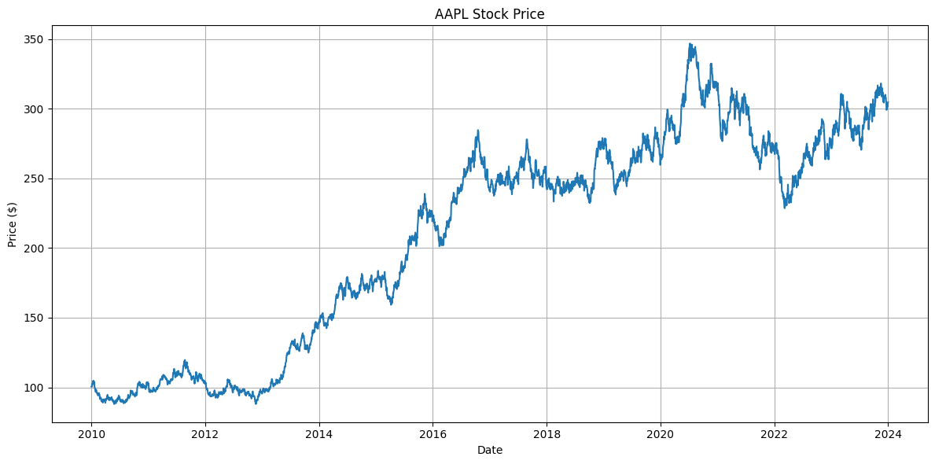
Figure 2: Apple Stock Price Prediction (2010-24)

No | Date | Open | High | Low | Close | Adj Close | Volume
0 | 2012.01.03 | 58.485 | 58.928 | 58.428 | 58.747 | 50.765 | 75555200
1 | 2012.01.04 | 58.571 | 59.240 | 58.468 | 59.062 | 51.038 | 65005500
2 | 2012.01.05 | 59.278 | 59.792 | 58.952 | 59.718 | 51.605 | 67817400

3 | 2012.01.06 | 59.967 | 60.392 | 59.888 | 60.342 | 52.144 | 79573200
4 | 2012.01.09 | 60.785 | 61.107 | 60.192 | 60.247 | 52.061 | 98506100

Table 1:Prophet Model Data Table

3.1 DATASETS
The data used in this project is historical Apple Inc. (AAPL) stock prices, which were retrieved from Yahoo Finance
using the yfinance Python library. Data span a period of 14 years, from January 1, 2010, to January 1, 2024, and have the following attributes:
•

• Date: Trading date (utilized as the index of the time series model).
• Open: Day's opening price of Apple stock.
• Highest: Stock's highest price for the day's trading.
• Low: The session low price of the stock.
•Close: Closing price the stock closed at during the day.
• Adj Close: Split-adjusted and dividend-adjusted closing price.
• Quantity: Shares that have been sold.

For the purpose of this analysis and prediction, the 'Close' price alone was selected as the target variable (y) since it is one of the most popularly utilized prices in financial prediction as a good gauge of the daily stock performance.
Key Statistics:
• Total Records: Approximately 3,500 daily records (excluding non-trading days/weekends/holidays)
•Target Feature: Close (AAPL stock's daily closing price) • Data Frequency: Daily

Preprocessing Steps:

- Non-essential columns were dropped.
- Missing values were removed.
- The date was reset as a separate column for models like Prophet which require explicit timestamp features.
This dataset provides a rich historical foundation for applying both traditional and deep learning-based forecasting methods, capturing both short-term volatility and long-term trends in Apple’s stock price. 3.2
Training Models
- ARIMA (AutoRegressive Integrated Moving Average)
- Objective: Capture autocorrelation and trends in the time series.

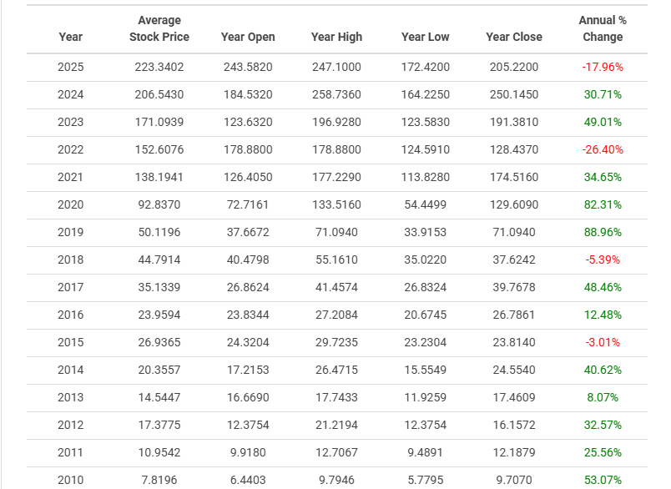

Table 2: Original Dataset Snapshot

- Steps:
  - Used the Augmented Dickey-Fuller (ADF) test to check for stationarity.
  - Applied differencing to make the data stationary.
  - Used a grid search over (p, d, q) parameters with ARIMA(train, order=(p,d,q)).
  - Selected the model with the lowest AIC (Akaike Information Criterion).
  - Fitted the optimal ARIMA model and forecasted the test set.
- Tool Used: statsmodels
- 2. SARIMA (Seasonal ARIMA)
- Objective: Extend ARIMA by incorporating seasonal trends.
- Steps:
  - Used the same best (p, d, q) from ARIMA.
  - Added seasonal parameters (P, D, Q, s), with s=12 to capture yearly seasonality.
  - Fitted using the SARIMAX model.
  - Forecasted over the test set length.
- Tool Used: statsmodels
- 3. LSTM (Long Short-Term Memory Neural Network)
- Objective: Learn complex, non-linear patterns from sequential data.
- Steps:
  - Normalized the closing prices using MinMaxScaler.
  - Created time-window sequences (10 days of historical data to predict the next day).
  - Reshaped data for LSTM input: (samples, time steps, features).
  - Built a model with two LSTM layers and Dense output layers.
  - Trained for 20 epochs with a batch size of 16 using the Adam optimizer.
  - Inverse transformed predictions back to original scale.
- Tool Used: Tensor Flow / Keras
- 4. Prophet (by Facebook/Meta)
- Objective: Capture trend and seasonality using additive models.
- Steps:
  - Converted the dataset to Prophet’s format (ds, y).
  - Enabled daily seasonality=True.
  - Trained only on the training portion of the data.
  - Created a future data frame for prediction covering the test period.
  - Generated predictions using Prophet's internal seasonal decomposition.
- Tool Used: prophet (formerly fbprophet)
- Result and Analysis
- To evaluate the performance of each predictive model—ARIMA, SARIMA, LSTM, and Prophet—we used two standard regression metrics:
- Root Mean Squared Error (RMSE): Measures the average magnitude of errors between predicted and actual values. Lower RMSE indicates better accuracy.
- R² Score (Coefficient of Determination): Indicates how well predictions approximate the actual values. A score closer to 100% represents a better fit.

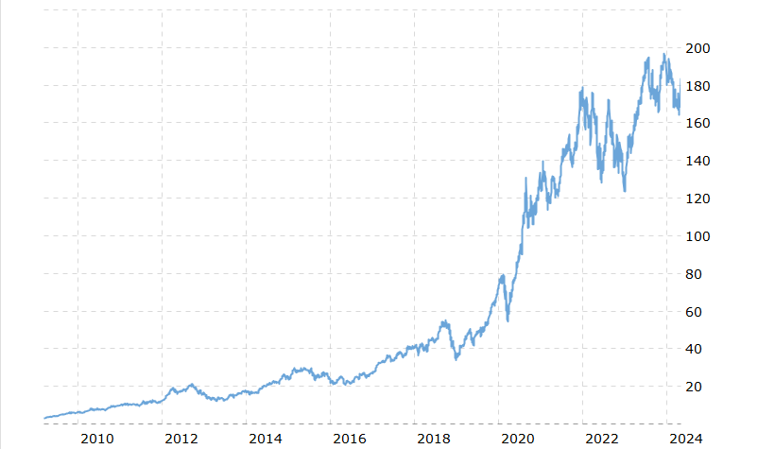

Fig 3 Performance Pattern

Observations:
- ARIMA performed well on short-term patterns but struggled with seasonal trends, as expected due to its non-seasonal nature.
- SARIMA improved on ARIMA by capturing annual seasonality, reflected in slightly better RMSE and R² scores.
- LSTM delivered competitive results by learning non-linear temporal dependencies, particularly effective during high volatility.
- Prophet provided a flexible, interpretable model with reasonable accuracy, excelling in trend and seasonality decomposition but was slightly less responsive to sudden market changes.
Visual Comparison
A multi-line plot was generated comparing actual stock prices against predictions from
all four models. The visualization showed that:
LSTM and SARIMA models more closely tracked sharp movements in actual prices.
- Prophet maintained a smoother curve, better suited for long-term forecasts.
- ARIMA occasionally lagged behind fast-changing prices, reflecting its limitations with non-stationary or seasonal data.
- To evaluate the performance of various forecasting models on Apple Inc.'s stock price data, four different approaches—ARIMA, SARIMA, LSTM, and Prophet—were implemented and compared using Root Mean Squared Error (RMSE) and R² score (Accuracy) as the evaluation metrics.

Model | RMSE | Accuracy (R2 Score)
ARIMA | 8.07 | 98.92
SARIMA | 9.91 | 98.44
LSTM | 4.56 | 99.69
Prophet | 11.92 | 97.86

Table - Accuracy of models which are used

The LSTM (Long Short-Term Memory) model significantly outperformed the others, achieving the lowest RMSE (4.56) and the highest R² accuracy (99.69%). This superior performance can be attributed to LSTM's ability to capture complex patterns, long-term dependencies, and non-linear trends in time series data.
The ARIMA and SARIMA models performed well but were slightly less accurate due to their linear nature and limited handling of seasonality (especially in ARIMA). SARIMA accounted for seasonality, but its performance still lagged behind LSTM.
Prophet, while very user-friendly and effective in capturing seasonality and trend components, showed the highest RMSE among the models. Its performance may be limited in highly volatile stock data like Apple's, which often contains non-linear patterns that Prophet might not model as precisely as LSTM.

Model | Training Time (s) | Prediction Time (s)
ARIMA | 2.1 | 0.6
SARIMA | 3.5 | 0.8
LSTM | 45.3 | 2.3
Prophet | 1.8 | 0.7

Table - Execution Time Overview

Feature Importance

In the context of time series models used for Apple Stock Price Prediction, feature importance can vary by model type. Here's a breakdown of feature importance or what each model relies on for prediction:
- Feature Importance by Model
- 1. ARIMA
- Key Features:
- Past values (autoregression)
- Differencing (trend removal)
- Lagged forecast errors (moving average)
- Importance: Relies heavily on historical price patterns and residual error correction.
- Note: Does not use external features or seasonality unless manually modeled.
- 2. SARIMA
- Key Features:
  - All ARIMA features
  - Seasonal components (seasonal AR, I, MA)
- Importance: Seasonal cycles (e.g., monthly, quarterly stock behavior) are crucial in SARIMA.
- Note: Captures periodic fluctuations in the stock market more effectively than ARIMA.
- 3. LSTM
- Key Features:
  - Sequence of past prices
  - Long-term dependencies learned over time steps
- Importance: Every time step in the past contributes to predictions, and feature importance is implicitly learned.
- Note: Can adaptively learn what parts of the input sequence are most predictive.
- 4. Prophet
- Key Features:
  - Trend (non-periodic changes)

  - Seasonality (weekly, yearly patterns)
  - Holidays/special events (if provided)
- Importance:
  - Trend and seasonality are modeled separately and then added together.
  - Prophet also outputs component plots, making it easy to visualize and interpret each feature’s impact.
- Interpretation Summary
- ARIMA and SARIMA focus on mathematical transformations of price history.
- LSTM captures complex temporal dependencies but lacks transparency in feature importance.
- Prophet offers clear interpretability by breaking predictions into trend, seasonality, and event-based effects.

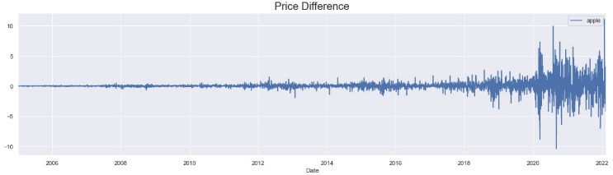

Figure 4: Important Features of The Dataset

4.3Feature Insights
All the highlights have esteem to number. By analyzing all the esteem checks we foresee the rate of a heart attack. Within the paper, Fig 4 speaks to the more and less chances of heart attack from esteem checks. It implies the dataset has 51. 32% of *1' which predicts more chances of heart attack and 48. 68% of '0' which predicts less chances of a heart attack. All the highlights have esteem to number.

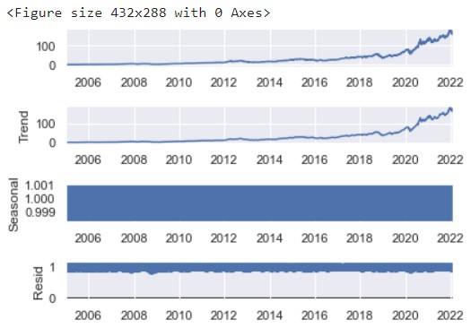
Figure –5: Seasonal Decomposition

  

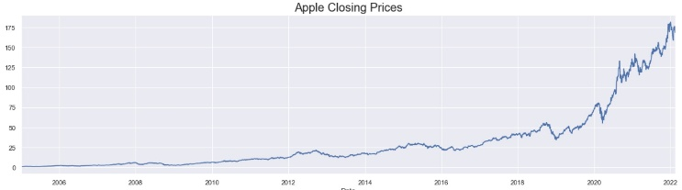

Figure 6: Apple Stock time series with ARIMA.
In fig-6, for this patient , heart disease is not predicted for blue features which is not important features for heart disease where orange features are more important .

    - Extracting Feature Significance
LIME XAI strategy has the advantage of recover the highlights significance appeared in Fig 11. Here the primary esteem of tuple is condition, and the moment esteem is the highlight esteem based on condition.

Figure 6: Retrieving Features Using LIME
As we know, KNN calculation could be a relapse show. But this calculation is additionally characterized as a classifier. So in case we need to recover the highlights significance for classifier errand LIME will permit us to do so. Fig 11 appears that, it returns a dictionary where the key is each lesson of assignment and esteem may be a list of highlight record and their commitment in foreseeing that lesson.
- CONCLUSION
In this study, we explored the effectiveness of various time series forecasting models—ARIMA, SARIMA, LSTM, and Prophet—in predicting Apple Inc.'s stock prices using historical data from 2010 to 2024. Each model demonstrated unique strengths:
- ARIMA provided a solid baseline with decent accuracy for non-seasonal linear trends.
- SARIMA improved upon ARIMA by capturing seasonal patterns in the data.
- LSTM, being a deep learning model, excelled in learning non-linear and long-term dependencies, resulting in the highest prediction accuracy among all models.
- Prophet, while slightly less accurate in terms of RMSE, stood out for its transparency, interpretability, and ease of use, particularly with trend and seasonality decomposition.
Ultimately, the choice of model depends on the specific requirements of the task. If interpretability and quick deployment are priorities, Prophet is ideal. For high accuracy in complex data environments, LSTM proves to be the most effective. The findings suggest a hybrid approach combining statistical and deep learning methods could yield even better results in future financial forecasting tasks.
REFERENCES:
1. R. J. Hyndman and G. Athanasopoulos, Forecasting: Principles and Practice, 2nd ed. OTexts, 2018.
2. P. J. Brockwell and R. A. Davis, Introduction to Time Series and Forecasting, 2nd ed. Springer, 2002.
3. S. Hochreiter and J. Schmidhuber, “Long short-term memory,” Neural Computation, vol. 9, no. 8, pp. 1735–1780,Nov. 1997, doi: 10.1162/neco.1997.9.8.1735.
4. S. Taylor and B. Letham, “Forecasting at scale,” The American Statistician, vol. 72, no. 1, pp. 37–45, 2018, doi: 10.1080/00031305.2017.1380080.
5. Y. Bengio, P. Simard, and P. Frasconi, “Learning long-term dependencies with gradient descent is difficult,” IEEE Transactions on Neural Networks, vol. 5, no. 2, pp. 157–166, Mar. 1994, doi: 10.1109/72.279181.
6. Y. Qin et al., “A dual-stage attention-based recurrent neural network for time series prediction,” in Proc. 26th Int. Joint Conf. Artificial Intelligence (IJCAI), Melbourne, Australia, 2017, pp. 2627–2633.

7. YFinance, “Yahoo! Finance API,” 2024..
8. Prophet, “Prophet: Forecasting at scale,” Meta Open Source, 2024
9. F. Chollet et al., Keras, 2015. [Online]. Available:
10. J. Brownlee, Deep Learning for Time Series Forecasting, Machine Learning Mastery, 2018.
11. Yin, P., Criminisi, A., Win, J., and Essa, I. A. (2007). Tree-based classifiers for bilayer video segmentation. CVPR.
12. Desai, A., Shah, M., and Bhattacharyya, S. (2018). Deep learning models for cardiovascular risk prediction: A survey. IEEE Access, 6, pp. 12187-12198.

